Lab 10. Call an external API from Flow with the HTTP action

**Author:** Serge Luca aka “Doctor Flow”

**Learning objective:** call an external REST API from Flow

**Duration:** 15 minutes

**Prerequisites**: calling an external api requires a Premium connector.

Tasks:

1. Go to the site <https://weatherstack.com/>and sign-up for a free account; you will get a key that you will use in Flow. The key shown in the lab has expired; you should generate a new one.
2. In your browser paste the following query (use your own key for the parameter access_key).

[http://api.weatherstack.com/current?access_key=96380665c7c7dc1b14b87493ee253a0d&query=paris](http://api.weatherstack.com/current?access_key=96380665c7c7dc1b14b87493ee253a0d&query=paris&days=3)

1. You should get a response similar to this one:

{"request":{"type":"City","query":"Paris, France","language":"en","unit":"m"},"location":{"name":"Paris","country":"France","region":"Ile-de-France","lat":"48.867","lon":"2.333","timezone_id":"Europe\/Paris","localtime":"2019-09-25 19:37","localtime_epoch":1569440220,"utc_offset":"2.0"},"current":{"observation_time":"05:37 PM","temperature":18,"weather_code":116,"weather_icons":["https:\/\/assets.weatherstack.com\/images\/wsymbols01_png_64\/wsymbol_0002_sunny_intervals.png"],"weather_descriptions":["Partly cloudy"],"wind_speed":19,"wind_degree":220,"wind_dir":"SW","pressure":1008,"precip":0.8,"humidity":68,"cloudcover":75,"feelslike":18,"uv_index":5,"visibility":10,"is_day":"yes"}}

1. Create Flow a started from a Button, name it **weather**:

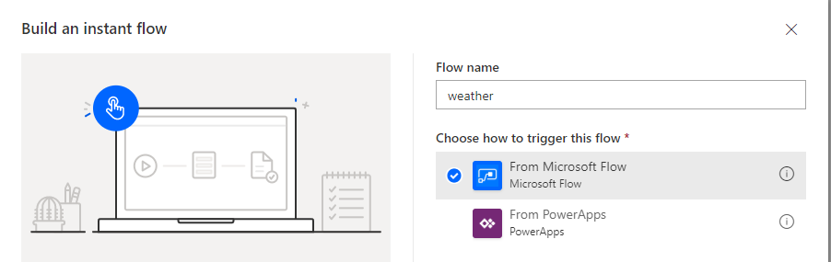

1. Add an HTTP action (this requires P1 licenses)
2. Copy and paste your query in the HTTP action; the value just after ”key=” is your private key; the value after q= is the city. The key provided below is probably not valid anymore; you should regenerate a new key.

[http://api.weatherstack.com/current?access_key=96380665c7c7dc1b14b87493ee253a0d&query=paris](http://api.weatherstack.com/current?access_key=96380665c7c7dc1b14b87493ee253a0d&query=paris&days=3)

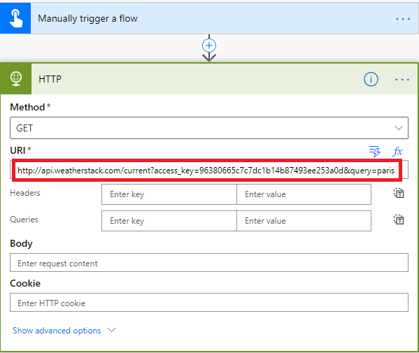

1. Save the Flow and run it.
2. Check the output of the HTTP action; you should have something like this:

{

"request": {

"type": "City",

"query": "Paris, France",

"language": "en",

"unit": "m"

},

"location": {

"name": "Paris",

"country": "France",

"region": "Ile-de-France",

"lat": "48.867",

"lon": "2.333",

"timezone_id": "Europe/Paris",

"localtime": "2019-09-25 19:52",

"localtime_epoch": 1569441120,

"utc_offset": "2.0"

},

"current": {

"observation_time": "05:52 PM",

"temperature": 18,

"weather_code": 116,

"weather_icons": [

"https://assets.weatherstack.com/images/wsymbols01_png_64/wsymbol_0004_black_low_cloud.png"

],

"weather_descriptions": [

"Partly cloudy"

],

"wind_speed": 24,

"wind_degree": 240,

"wind_dir": "WSW",

"pressure": 1008,

"precip": 0.8,

"humidity": 73,

"cloudcover": 75,

"feelslike": 18,

"uv_index": 0,

"visibility": 10,

"is_day": "no"

}

}

1. Now we will store the current temperature in a variable. Create a string variable named **city temperature**:

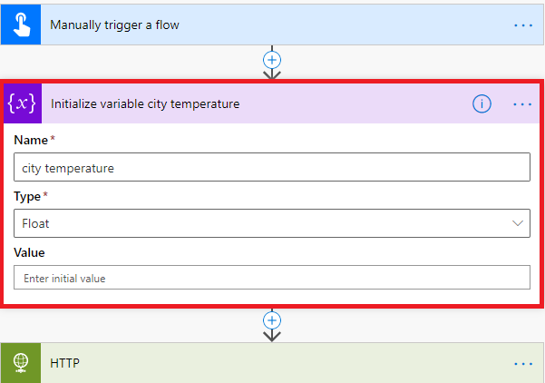

1. Add a **Set variable** action that will grab the temperature, by adding a custom expression:

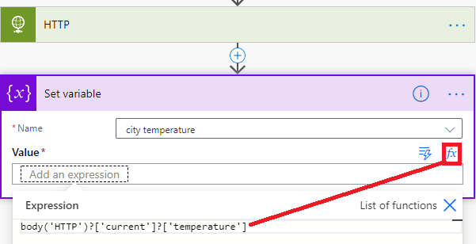

1. Run the Flow and check the variable content.